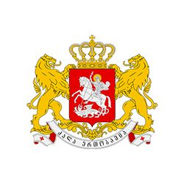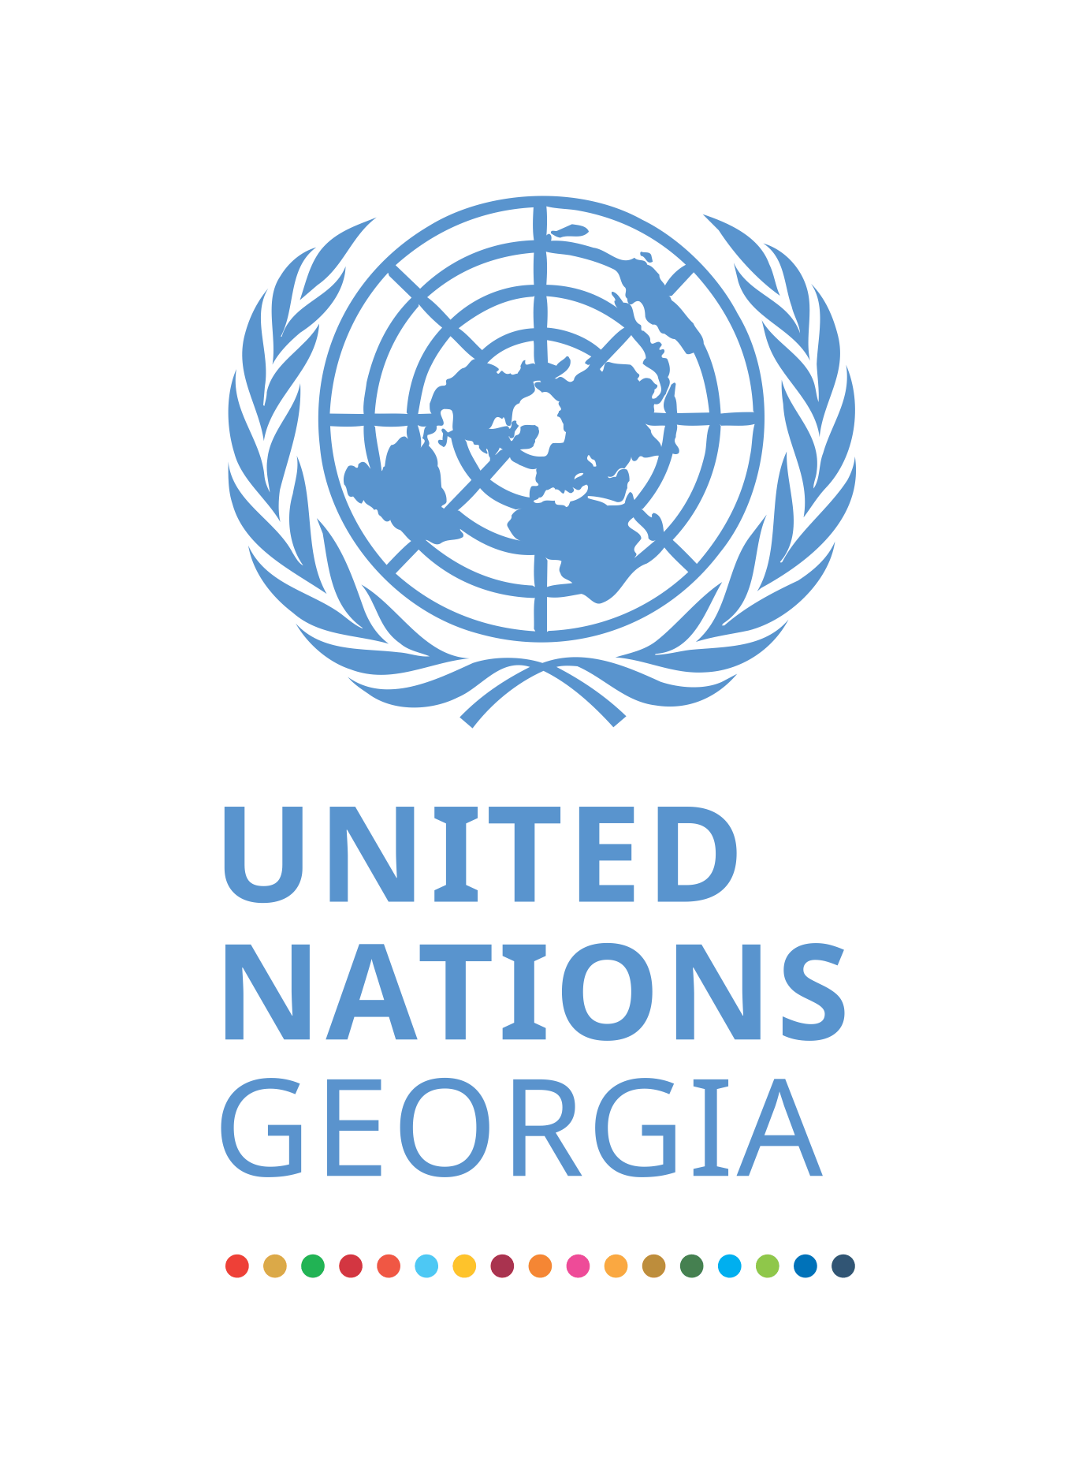
VALIDATION WORKSHOP
ON UNITED NATIONS SUSTAINABLE DEVELOPMENT COOPERATION FRAMEWORK FOR GEORGIA
2021-2025
DATE: 18 September, 2020
VENUE: TBC
Working language: GEO/ENG

10:00 – 10:10 Welcome
Ms. Natia Mezvrishvili, Head of Administration of the Government of Georgia
H.E. Sabine Machl, UN Resident Coordinator
10:10 – 10:50 United Nations Sustainable Development Cooperation Framework (UNSDCF) 2021-2025
- Presentation [20 min]
- Discussion [20 min]
10: 50 – 11:40 Presentation Country Programme Document (UNICEF, UNFPA, UNDP)
- 10:50 – 11:00 Presentation UNICEF Country Programme Document (CPD)
- 11:00 – 11:10 Presentation of UNFPA Country Programme Document (CPD)
- 11:10 – 11:20 Presentation UNDP Country Programme Document (CPD)
- 11:20 – 11:40 Discussion
11:40 – 11:50 Closing Remarks

